Lesson 21: Solution Sets to Inequalities with Two Variables
Classwork
Exercise 1
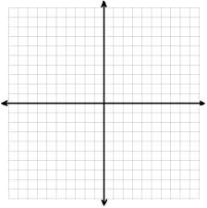
  - Circle each ordered pair $(x,y)$that is a solution to the equation $4x-y≤10$.

    - $\left(3,2\right)$ $\left(2, 3\right)$ $\left(-1,-14\right)$ $\left(0,0\right)$ $\left(1,-6\right)$

    - $\left(5,10\right)$ $\left(0, -10\right)$ $\left(3,4\right)$ $\left(6,0\right)$ $\left(4,-1\right)$

  - Plot each solution as a point $(x,y)$ in the coordinate plane.

  - How would you describe the location of the solutions in the coordinate plane?

Exercise 2
  - Discover as many additional solutions to the equation $4x-y≤10$ as possible. Organize your solutions by plotting each solution as a point $(x,y)$ in the coordinate plane. Be prepared to share the strategies used to find your solutions.

  - Graph the line $y=4x-10$. What do you notice about the solutions to the inequality $4x-y≤10$ and the graph of the line$y=4x-10?$

  - Solve the inequality for $y$.

  - Complete the following sentence: If an ordered pair is a solution to $4x-y≤10,$then it will be located
the line $y=4x-10$. Explain how you arrived at your conclusion.
Example 1
The solution to $x+y=20$ is shown on the graph below.

  - Graph the solution to $x+y≤20$
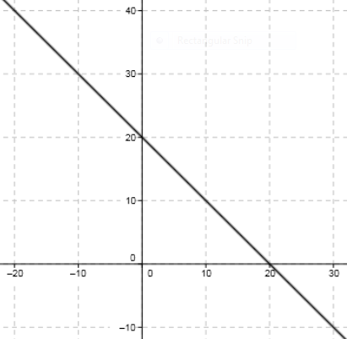

  - Graph the solution to $x+y≥20$
  - Graph the solution to $x+y<20$

  - Graph the solution to $x+y>20$

Steps to graphing inequalities with two variables
Solve for y | Graph the boundary line  Use a dashed line for  < or >  Use a solid line for  < or > | Shade all solutions  Above  > or >  Below  < or < | Check  Use an ordered pair in the shaded region

Graph the inequalities and check with an ordered pair.
3x + y < 2 x – 2y < 4

Graphing Vertical and Horizontal Inequalities
Horizontal Lines | Vertical Lines
y < b or y < b  Shade below | x < a or x < a  Shade to the left
y > b or y > b  Shade above | x > a or x > a  Shade to the right

x > -2 y < -2

Exercises 3–4
- Which of the following inequalities are linear inequalities?
  - $x-y=10$
  - $x-y<10$
  - $y>x-10$
  - $y≥x$
  - $x≥y$
  - $y=5$
  - $y<5$
  - $x≥5$
  - $y≠1$
  - $x=0$
  - $x>0$
  - $y<0$
  - $x^{2}-y=0$
  - $x^{2}+y^{2}>0$
  - $xy≤0$

A half plane is the graph of a solution set in the Cartesian coordinate plane of an inequality in two real-number variables that is linear and strict.

- Describe in words the half-plane that is the solution to each inequality.
  - $y≥0$

  - $x<-5$

  - $y≥2x-5$

  - $y<2x-5$
Lesson Summary
An ordered pair is a solution to a two variable inequality if, when each number is substituted into its corresponding variable, it makes the inequality a true number sentence.
Each ordered pair of numbers in the solution set of the inequality corresponds to a point on the coordinate plane. The set of all such points in the coordinate plane is called the graph of the inequality.
The graph of a linear inequality in the coordinate plane is called a half-plane.

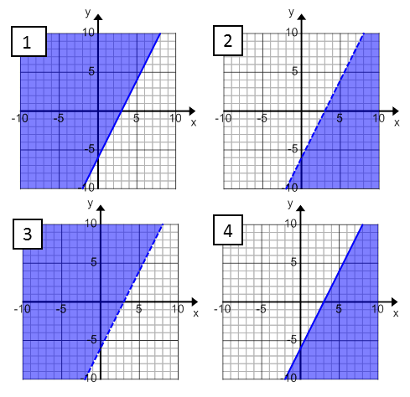
Problem Set

- Match each inequality with its graph. Explain your reasoning.
  - $2x-y>6$

  - $y≤2x-6$

  - $2x<y+6$

  - $2x-6≤y$

- Graph the solution set in the coordinate plane. Support your answer by selecting two ordered pairs in the solution set and verifying that they make the inequality true. Use your own graph paper.

- $-10x+y>25$ | - $-6≤y$ | - $y≤-7.5x+15$
- $2x-8y≤24$ | - $3x<y$ | - $2x>0$
- Marti sells tacos and burritos from a food truck at the farmers market. She sells burritos for $3.50 each, and tacos for $2.00 each. She hopes to earn at least $120 at the farmers market this Saturday.
(Show all work on your graph paper)
  - Identify 3 combinations of tacos and burritos that will earn Marti more than $120.
  - Identify 3 combinations of tacos and burritos that will earn Marti exactly $120.
  - Identify 3 combinations of tacos and burritos that will not earn Marti at least $120.
  - Graph your answers to parts (a–c) in the coordinate plane and then shade a half-plane that contains all possible solutions to this problem.
  - Create a linear inequality that represents the solution to this problem. Let $x$ equal the number of burritos that Marti sells, and let y equal the number of tacos that Marti sells.
  - Are the points (10, 49.5) a solution to inequality you created in part (e)? Explain your reasoning.

